1. **Agenda**:
   1. You want to copy files/folders into a running container or out of a running container.
2. **Command**:
   1. docker cp
3. Copying contents from Local host into the container.
   1. 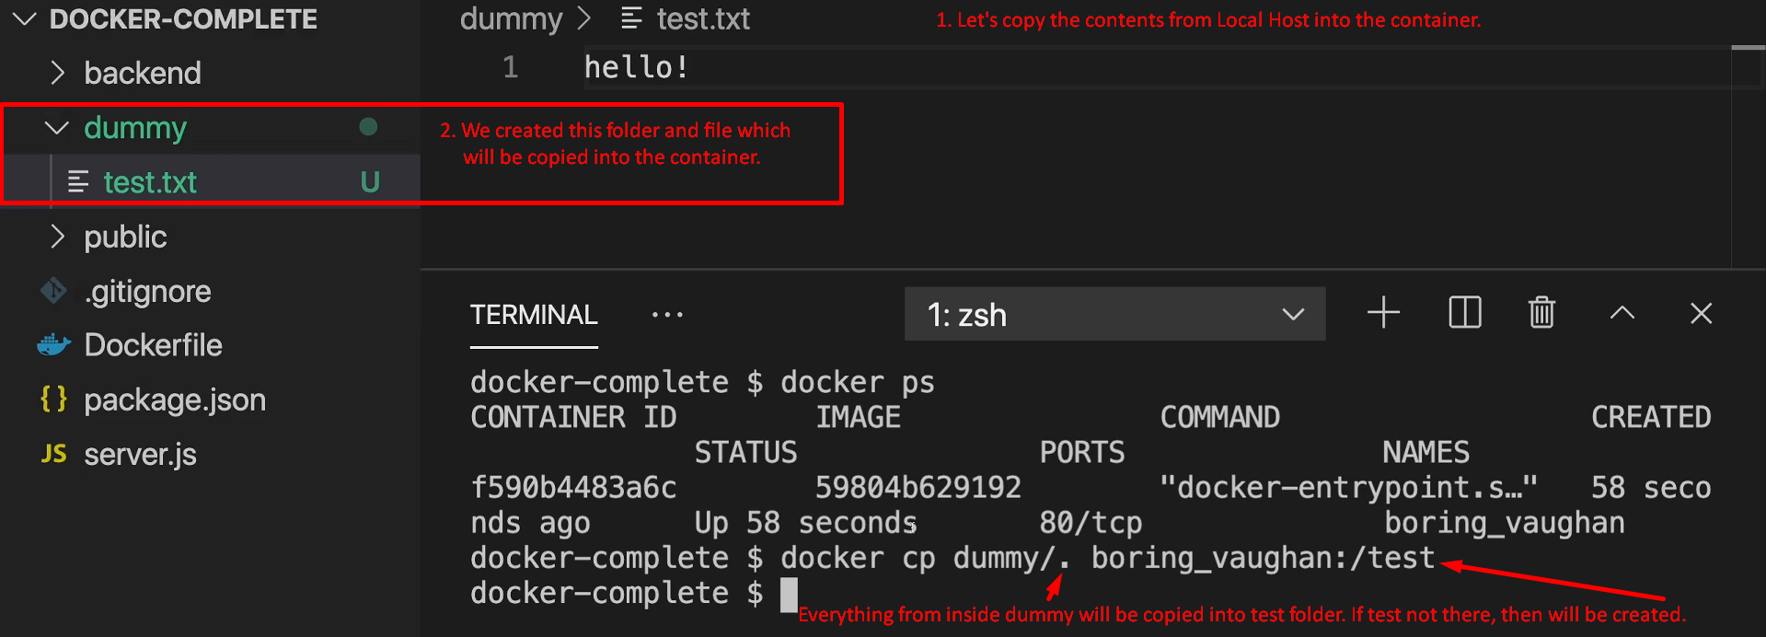
4. Copying contents from the container on to local host.
   1. Graphical user interface, text

      Description automatically generated
5. **Pros and Con**
   1. **Pros**: This command is useful in some cases where you don’t need to rebuild the image for the changes.  
      Such as configuration files.
      1. If your container is generating a bunch of log files, you can copy out of container on local host machine.
   2. **Con**:
      1. Not possible to replace a file which is currently being executed such as java files, server.js files.